

**KPLABS Course**

**AWS Certified Cloud Practitioner 2022**

**Important Pointers for Exams**

## **ISSUED BY**

Zeal Vora

## **REPRESENTATIVE**

[instructors@kplabs.in](mailto:instructors@kplabs.in)

# 

## **Module 1: Fundamentals of Cloud & Important Definitions**

Be familiar with the fundamentals of Cloud Computing.

Know basic important definitions.

| Elasticity | Allows scaling service based on demand.  It can make AWS workload cost-effective based on dynamic user demand. |
| --- | --- |
| On-Demand | Allows customers to launch servers and services whenever they intend to. |
| High-Availability | Architectural Design to accommodate the failure of any single component. |
| Least Privilege | Grant access to only resources needed to perform the task. |

## 

## 

## **Module 2: AWS Global Infrastructure**

| **Sr No** | **Topics** | **Description** |
| --- | --- | --- |
| 1 | Regions | Physical locations spread across the globe to host your data. |
| 2 | Availability Zones | AZ is a combination of one or more data centers in a region.  Minimum 2 AZ needed to achieve high-availability. |
| 3 | Edge Locations | An edge location is where end-users access services located at AWS.  Delivers contents close to the users.  Caches responses so it reduces traffic on the origin server.  CloudFront can be used.  Will help improve the overall latency and improve the performance of the website. |

The primary aim of distributing servers across availability zones is to prepare for failure.

## 

## **Module 3: Elastic Compute Cloud (EC2)**

Before you launch an EC2 instance, you will have to select the region.

AMI is basically an OS for EC2 instance. The OS can have its own set of software configurations.

We can launch multiple EC2 instances from a single AMI.

## 

## 

## **Module 4: EBS and Instance Store**

4.1 Elastic Block Store (EBS)

AWS EBS provides persistent block storage volumes for AWS EC2 instance.

4.2 Instance Store:

Fast performance but will be lost if you stop your server.

## **Module 5: Simple Storage Service**

| **Sr No** | **Storage Classes** | **Description** |
| --- | --- | --- |
| 1 | General Purpose | Recommended for frequently accessed data. |
| 2 | Infrequent Access | Long-lived infrequent accessed data. |
| 3 | Reduced Redundancy | Frequently accessed, non-critical data. |
| 4 | Intelligent-Tiering | Long-lived data with unknown access patterns. |
| 5 | One Zone-IA | Long-lived, infrequently accessed, non-critical data. |
| 6 | Glacier Deep Archive | Archive data that rarely need to be accessed.  Retrieval time in hours. |
| 7 | Glacier | Archived data with retrieval time in minutes to hours.  Suitable for use-case where durable low-cost storage needed. |

Know the difference between Buckets and Objects.

Buckets are like folders where you can store multiple objects.

S3 is a durable storage system and is based on object storage.

S3 can also be used for storing RDS backups.

S3 can also be used to host simple websites (low cost)

## **Module 7: Virtual Private Cloud (VPC)**

Allows us to define a custom network for our resources in AWS.

We can then implement minute controls.

VPC peering allows resources between two VPC’s to communicate with each other.

## **Module 8: Hybrid Cloud Architectures**

Hybrid Cloud Architectures is a combination of AWS and other platforms (on-premise / other cloud providers)

Direct Connect is used to connect AWS VPC to Datacenter environments

Direct Connect provides a dedicated network connection between on-premises and AWS.

Various services like Route53, Virtual Private Gateways (VGW) can be used in a hybrid design.

Services like Classic Load Balancer, Auto Scaling, are not supported in a hybrid design.

## **Module 9: Amazon Machine Image (AMI)**

Amazon Machine Image (AMI) is the master image from which new EC2 instances can be launched.

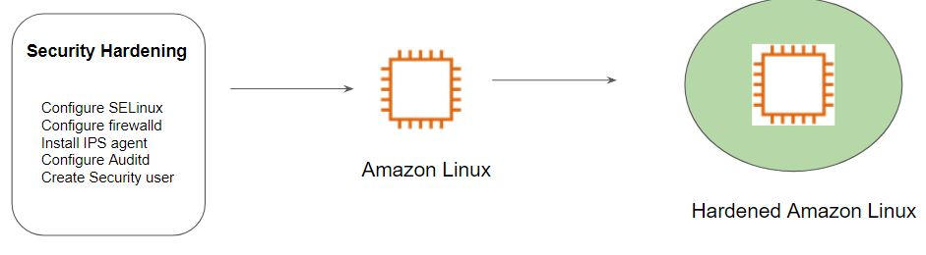

## **Module 10: AWS Snowball**

AWS Snowball is a data transport solution that accelerates moving terabytes to petabytes of data into and out of AWS using storage devices designed to be secure for physical transport.



## **Module 11: AWS Snowmobile**

AWS Snowmobile is an Exabyte-scale data transfer service used to move extremely large amounts of data to AWS.

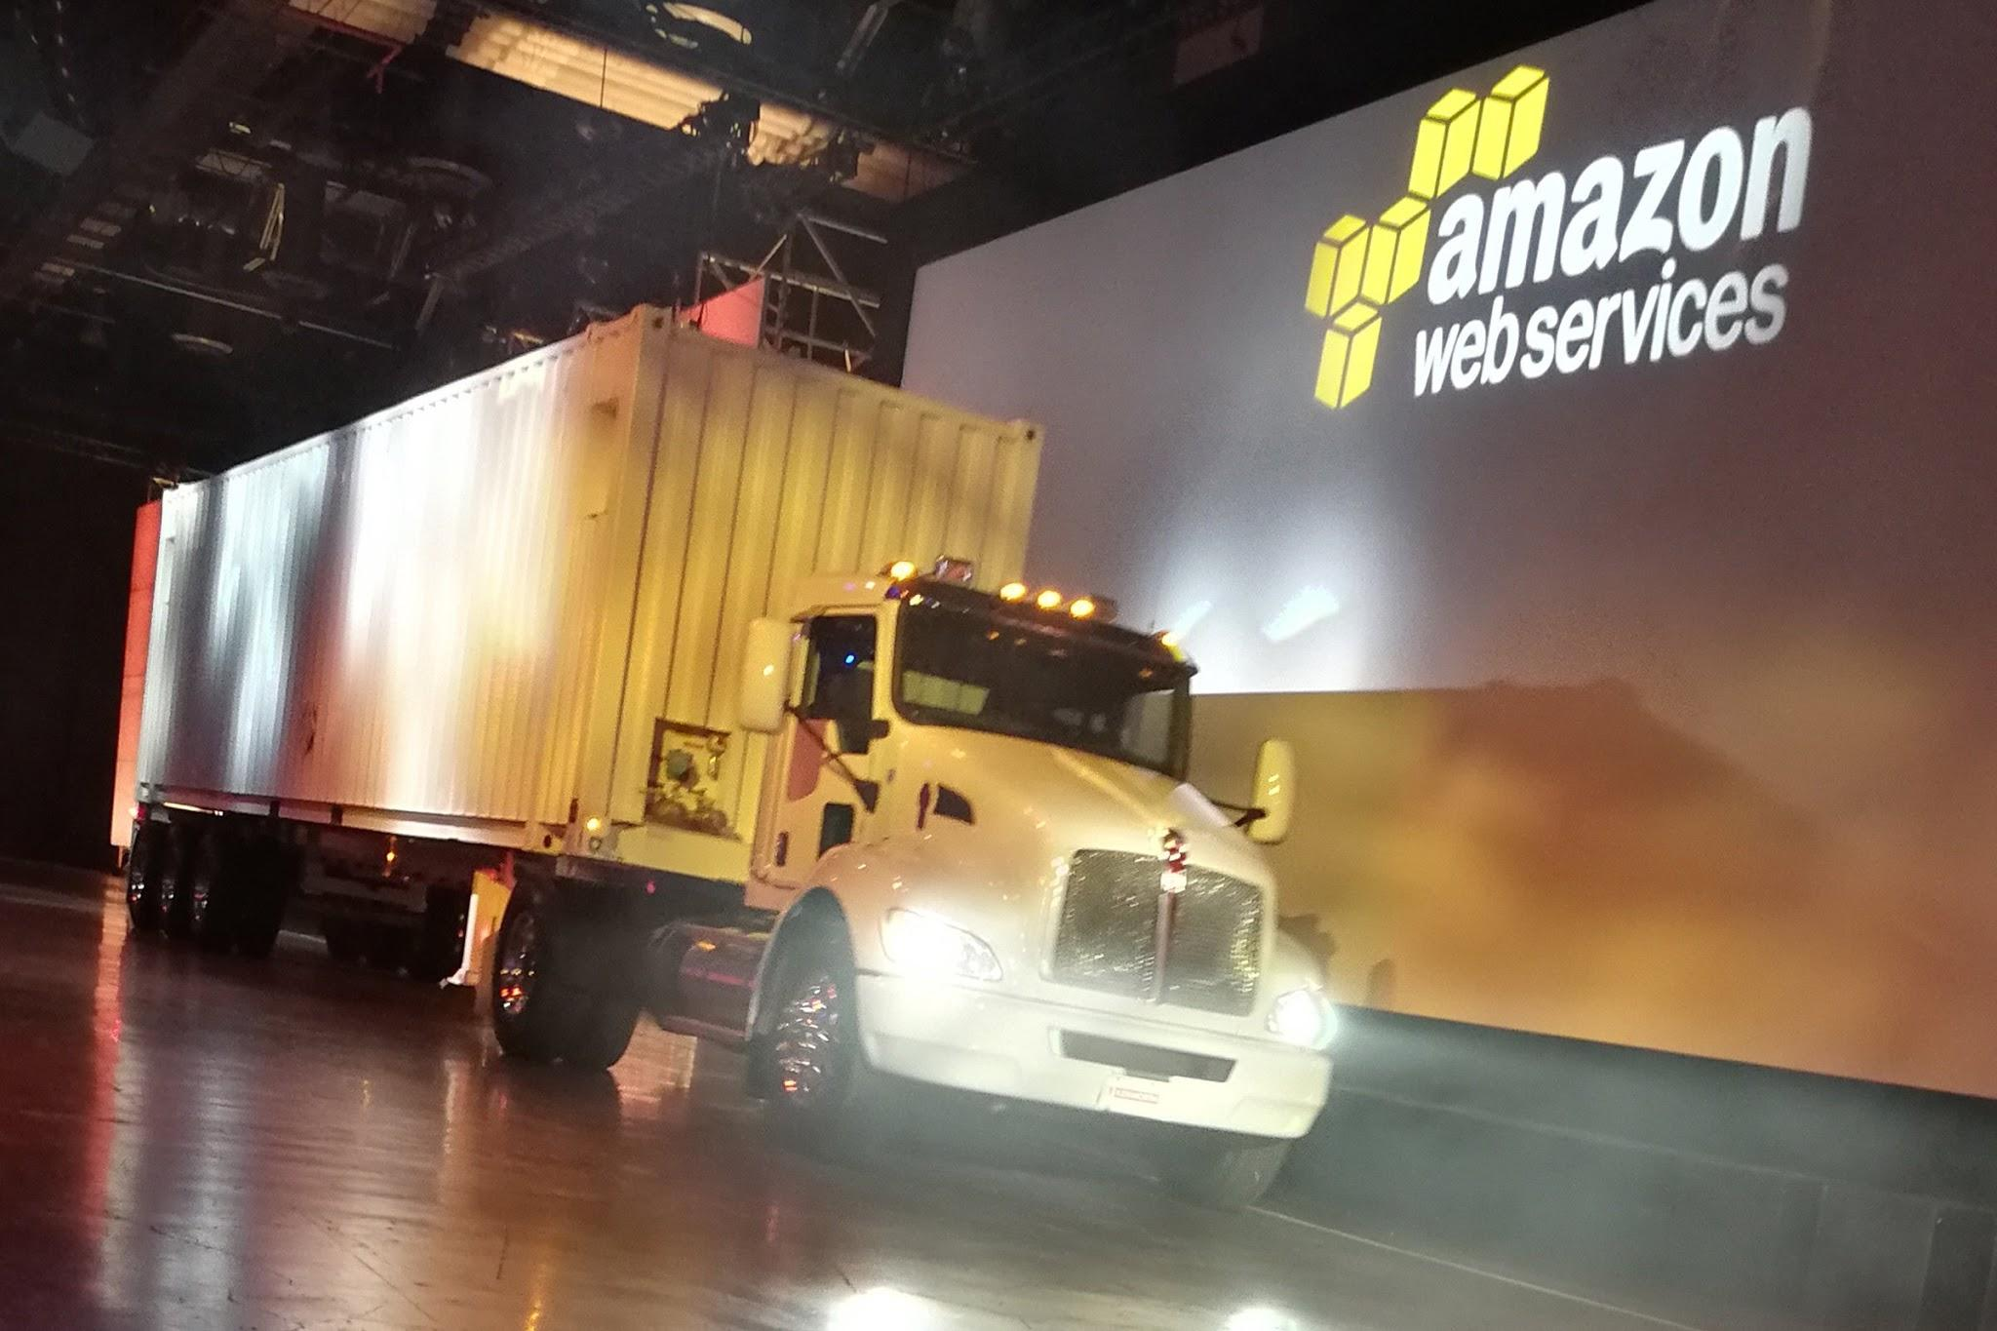

## 

## 

## **Module 12: AWS Elastic Load Balancers**

Allows users to distribute traffic across multiple EC2 instances.

ELB will automatically scale (behind the scenes) depending on the traffic pattern.

Type of Load Balancers:

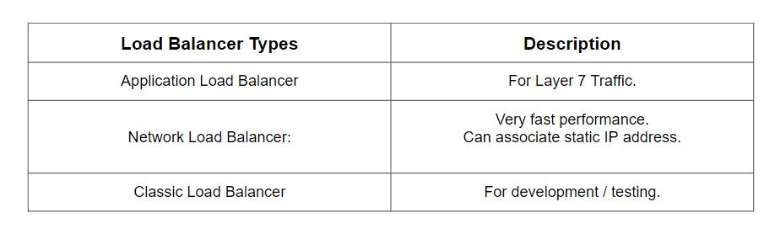

## 

## **Module 13: Shared Responsibility Model**

AWS is responsible for the physical security of the facilities as well as the infrastructure that includes compute, database, storage, and networking resources.

The customer is responsible for software, data, and access that sits on top of the infrastructure layer.



Be prepared for questions related to the Shared Responsibility Model.

Remember that when it comes to “Customer Data”, the responsibility falls to customer.

Some aspects like “Awareness and Training” are shared control between customers and AWS.

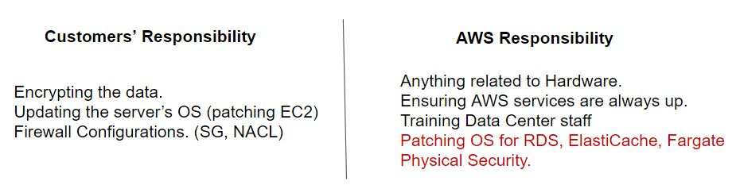

## **Module 14: Identity and Access Management (IAM)**

Users/Groups/Roles/Policies

If IAM user wants to access a specific AWS service, assign an IAM policy to it.

Access/Secret keys can be for AWS CLI operations (associated with IAM user)

For EC2 Instance, you can make use of IAM Role.

IAM Policies allows an administrator to control which user can do what operation.

For additional security, make use of MFA and strong passwords.

If you want to apply a set of policies to a large group of users, use IAM groups.

## 

## 

## **Module 15: AWS Shield**

Dedicated Service which protects against DDoS attacks.

Two variants: Shield Standard and Shield Advanced

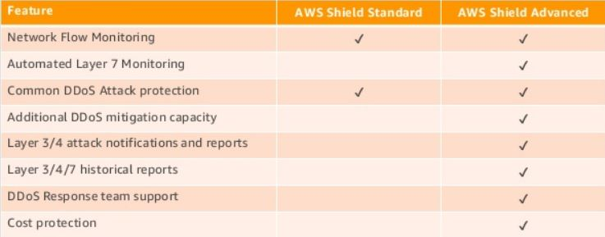

## **Module 16: Trusted Advisor**

AWS Trusted Advisor analyzes your AWS environment and provides best practice recommendations in five major categories:

Business and Enterprise Support customers have access to all the Trusted Advisor checks.

Remember the name of these checks categories.

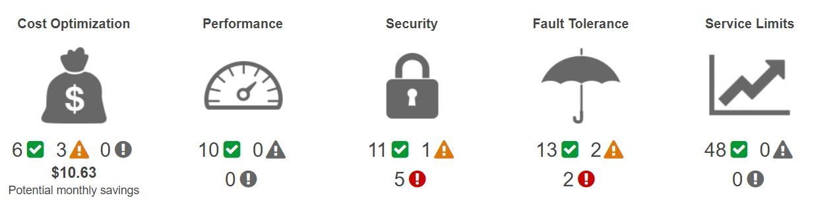

## **Module 17: AWS CloudTrail**

AWS CloudTrail is a service that enables governance, compliance, operational auditing, and risk auditing of your AWS account.

It records the activities in your AWS account so that Administrators can track which user has performed which operation in the AWS account.

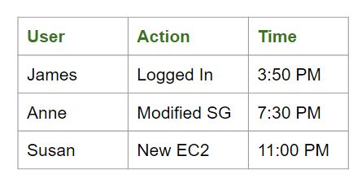

## **Module 18: AWS Config**

AWS Config allows customers to audit and monitor changes to AWS resources.

This service is also useful for change management purposes.

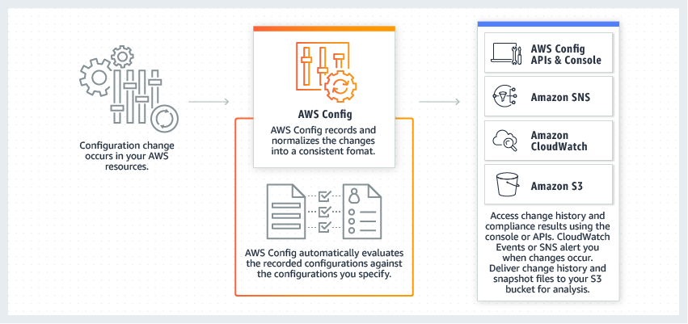

## 

## **Module 19: Firewalls**

Security Group acts as a virtual firewall for EC2 instances.

Network ACL applies at a subnet level instead of the EC2 instance level.

Managing both is the responsibility of the customer.

## **Module 20: Miscellenous Pointers for Security**

AWS Shield, AWS CloudFront, and WAF can protect against DDoS attacks.

AWS Classroom Training is also available for customers who want to learn about AWS and Security in an official instructor-led setting.

AWS Professional services can also guide an organization when the customer needs specialty level guidances. They even work with APN

## **Module 21: CloudFormation**

AWS CloudFormation allows us to deploy the infrastructure in the form of code.

It’s often also referred to as Infrastructure as Code solution.

Supports almost all the AWS services.

CloudFormation is a free service (resources created would be charged)

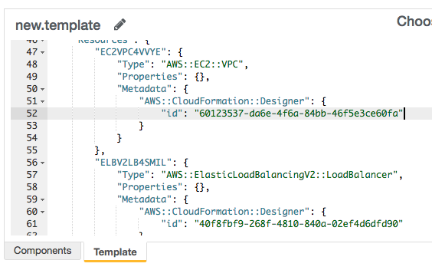

## **Module 22: AWS Elastic Beanstalk**

## 

You can simply upload your code and Elastic Beanstalk automatically handles the deployment, from capacity provisioning, load balancing, auto-scaling to application health monitoring.

AWS Elastic Beanstalk can manage and automate deployments in AWS.

Limited by what it can provision: EC2, RDS, Load Balancers, Security Groups.

## **Module 23: Serverless Computing**

AWS Lambda lets you run code without provisioning or managing servers.

You pay only for the compute time you consume - there is no charge when your code is not running.

Just upload your code and Lambda takes care of everything required to run and scale your code with high availability.

When you see “serverless” in question, Lambda is probably the right option.

AWS Serverless Platform NOT EC2, EMR.

Services that are part of the AWS Serverless platform can be SNS, DynamoDB, and others.

## **Module 24: CloudFront**

AWS CloudFront is a Content Delivery Network service.

CloudFront is a global service.

CloudFront is also one of the services which help during DDoS attacks.

Data can be cached across multiple edge locations (leads to lower latency)

Data is cached using AWS Edge Locations.

## **Module 25: Database Primer**

Relational Database (RDS)

NoSQL Database (DynamoDB)

Data Warehouse (Redshift)

In-Memory Databases - Redis and Memcached (ElastiCache)

25.1 Relational Database Service:

AWS RDS is a fully managed Relational Database Service in the cloud.

Simplifies database administration tasks.

Supports a wide variety of databases engines:

* MySQL
* PostgreSQL
* MariaDB
* Microsoft SQL Server
* Amazon Aurora
* Oracle

Various DB engines like MySQL, PostgreSQL, Microsoft SQL can also be hosted in EC2.

25.2 Important Pointers for Databases:

Various DB engines like MySQL, PostgreSQL, Microsoft SQL can also be hosted in EC2.

Aurora is one of the database services that can easily scale.

In Aurora, as your data grows, your cluster volume storage grows as well (storage scaling)

If there is a need for globally redundant databases, then RDS Read Replicas can be used.

## 

## **Module 26: Auto-Scaling**

Auto-Scaling allows us to scale up or down the servers depending on the demand.

We can define a minimum and maximum.

The minimum is the number of EC2 instances that are always running.

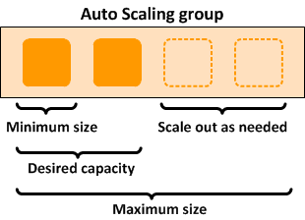

## 

## **Module 27: AWS Access Options**

We can access AWS in the following three ways:

* AWS Console (GUI)
* AWS Command Line Interface (CLI)
* AWS SDK

Access/Secret keys are used along with AWS CLI to connect to AWS resources.

Software Development Kit (SDK) allows access to AWS resources from application code.

## **Module 28: AWS CloudWatch**

Primarily a monitoring service that can monitor for various aspects like CPU, Disk, Network utilization, and others.

CloudWatch Logs allows users to centrally upload logs from all the servers.

CloudWatch logs allow real-time monitoring as well as adjustable retention.

## **Module 29: AWS ElastiCache**

ElastiCache is a fully managed AWS service that makes it easier to deploy, operate and scale an in-memory data-store or cache in the cloud.

Used for storing results associated with frequently accessed queries.

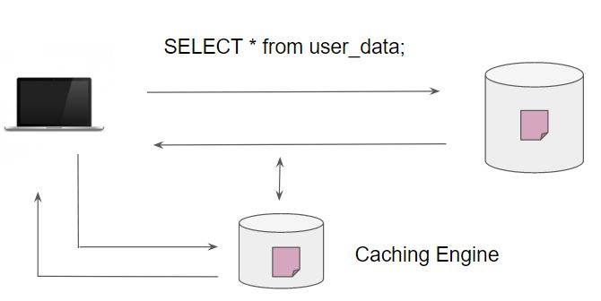

## 

## 

## **Module 30: Simple Queue Service (SQS)**

AWS SQS makes it simple and quite cost-effective to decouple the components of a specific application.

Used for an architectural design where loosely coupled components are needed.

Loosely Coupled System = Important Design Principle

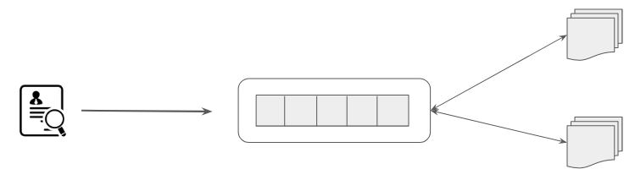

## 

## **Module 31: Serverless Computing**

AWS provides a set of fully managed services that you can use to build and run serverless applications

Examples:

Compute → AWS Lambda

Storage → AWS S3

Data Store → DynamoDB

App Integration → SQS, SNS

## **Module 32: Personal Health Dashboard**

AWS Personal Health Dashboard provides alerts and remediation guidance when AWS is experiencing events that may impact you.

Amazon Web Services publishes our most up-to-the-minute information on service availability. This is part of the Service Health Dashboard.

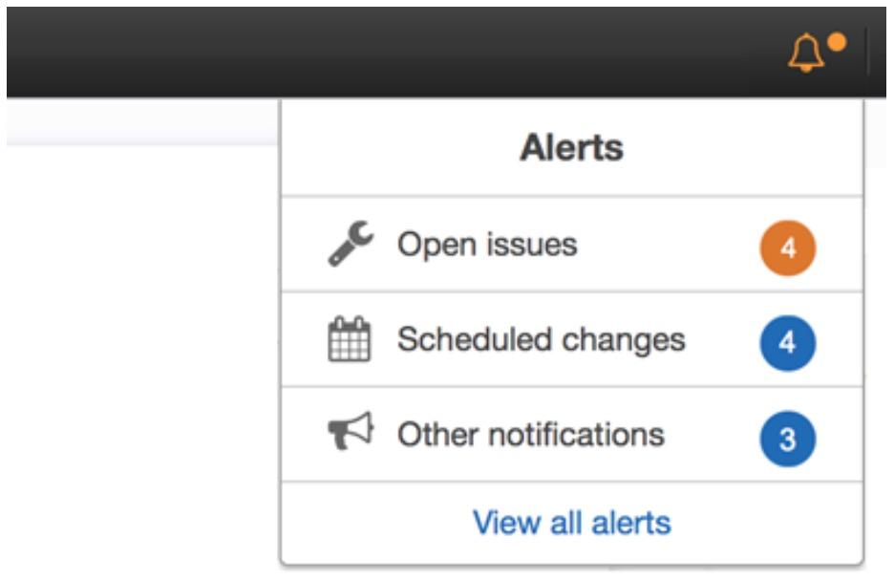

## **Module 33: Miscellaneous Pointers - Deployment**

Route53 is the DNS service based on AWS.

For Storage systems, if frequent read/write of data is needed, make use of block-based storage like EBS, EFS instead of object store like Glacier, S3.

For choosing the right region for an application, consider the following:

* Least latency to the clients (end users)
* Data sovereignty and compliance aspects.

Know that some services are regional while some are global.

* Example of Regional Service: ELB, EC2, Auto-Scaling, RDS, DynamoDB, S3
* Example of Global Service: Route53, CloudFront

Version Control, GIT → AWS Code Commit

AWS Rekognition can automatically detect objects from an image with a specific probability.

AWS Code Deploy and AWS OpsWorks are the services that can deploy applications in the on-premise servers.

Amazon Redshift is the data warehouse solution that customers can use in AWS.

AWS EFS is the shared file storage solution that can be used across EC2 instance and on-premise servers.

If applications within on-premise need to make use of AWS storage solutions, AWS Storage Gateway can be used.

## **Module 34: Consolidated Billing**

Part of the AWS Organizations service.

One bill for multiple AWS accounts.

Consolidated Billing allows us to have volume discounts.

Reserved Group instances are applied to all linked accounts.

## **Module 35: Free Things in AWS!**

* CloudFormation
* Identity and Access Management (IAM)
* Auto-Scaling
* Elastic Beanstalk
* AWS VPC
* Consolidated Billing
* AWS Forums, Whitepapers, Documentations, and blogs.

## **Module 36: Support Plans**

Enterprise Support Benefits from Technical Account Manager.

Minimum Support Plan for Chat/Phone Support is Business

One hour target response time for support cases - Business / Enterprise

Infrastructure Event Management is available for Enterprise Customers, and also to Business support customers but with an additional cost.

## 

## **Module 37: EC2 Pricing**

| **Sr No** | **EC2 Instance** | **Description** |
| --- | --- | --- |
| 1 | On-Demand Instances | Pay fixed-rate (at hourly/second basis) without any commitment. |
| 2 | Reserved Instances | You need to reserve capacity with a term of 1 to 3 years. A significant discount can be availed.  Convertible RI = Allows changing attributes.  Good for non-interruptible workloads.  Three Year, All Upfront, Standard RI = Highest Discount |
| 3 | Spot Instances | Good for applications with flexible start and end times (interruptible workloads)  Suitable for Infrequent, interruptible workloads.  Can provide discounts up to 90% |
| 4 | Dedicated Hosts | Physical EC2 server dedicated for use of a single customer. Generally used when licenses are server bound. |

## 

## **Module 38: Pricing Calculator**

Both of the following options can be used to estimate the cost in AWS.

38.1 Simple Monthly Calculator

* Used to check what a specific service usage would cost.
* It can be used to forecast the cost of workloads.

38.2 TCO Calculator (Total Cost of Ownership )

* Used for comparing the cost of running infrastructure on-premise vs Cloud.
* It can even generate reports that can be shared with the management.
* Be aware of what costs are included as part of TCO.
* Shared Responsibility Model of AWS can reduce the overall TCO.
* It’s recommended to use Reserved Instances in calculating pricing with TCO.
* Example: Anti-Virus cost is not included but Datacenter security cost can be the part.

## 

## 

## 

## **Module 39: Cost Allocation Tags**

After you have created tags and associated it with resources, you can then activate them in Billing and Cost Management console for cost allocation tracking

After you activate them, they appear on your cost allocation report.

If you want to track and categorize spending in detail, Cost Allocation Tags is a good feature.

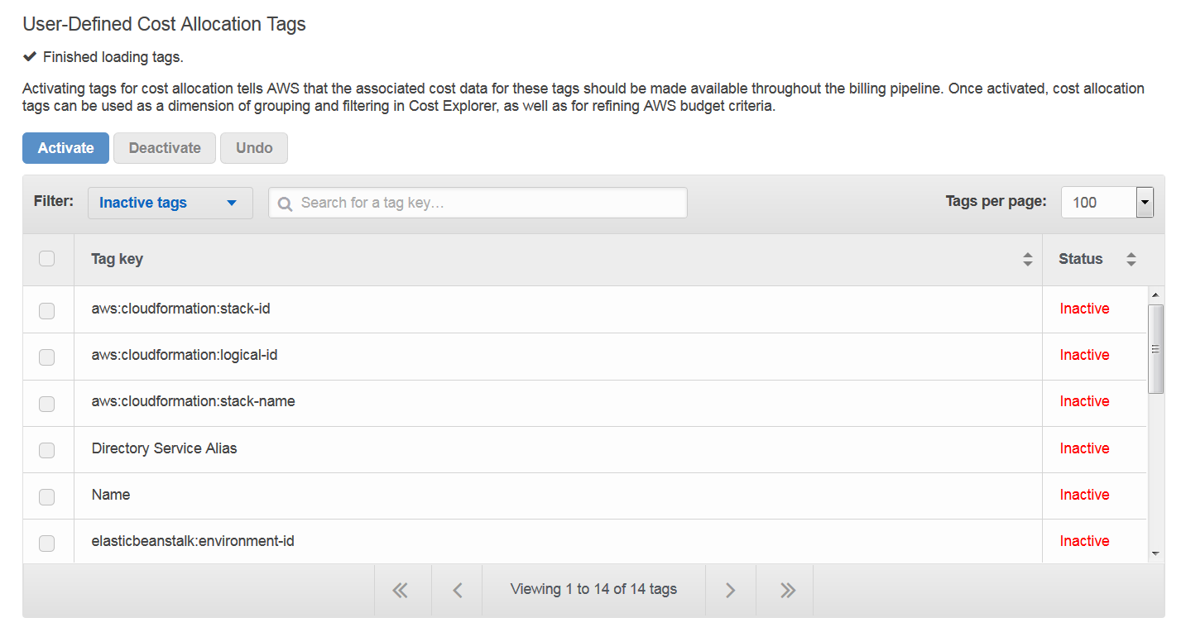

## **Module 40: AWS Cost Explorer**

Allows customers to visualize cost over a period of time.

Provides out of box reporting and tracking associated with Reserved Instances and it benefits across your AWS accounts.

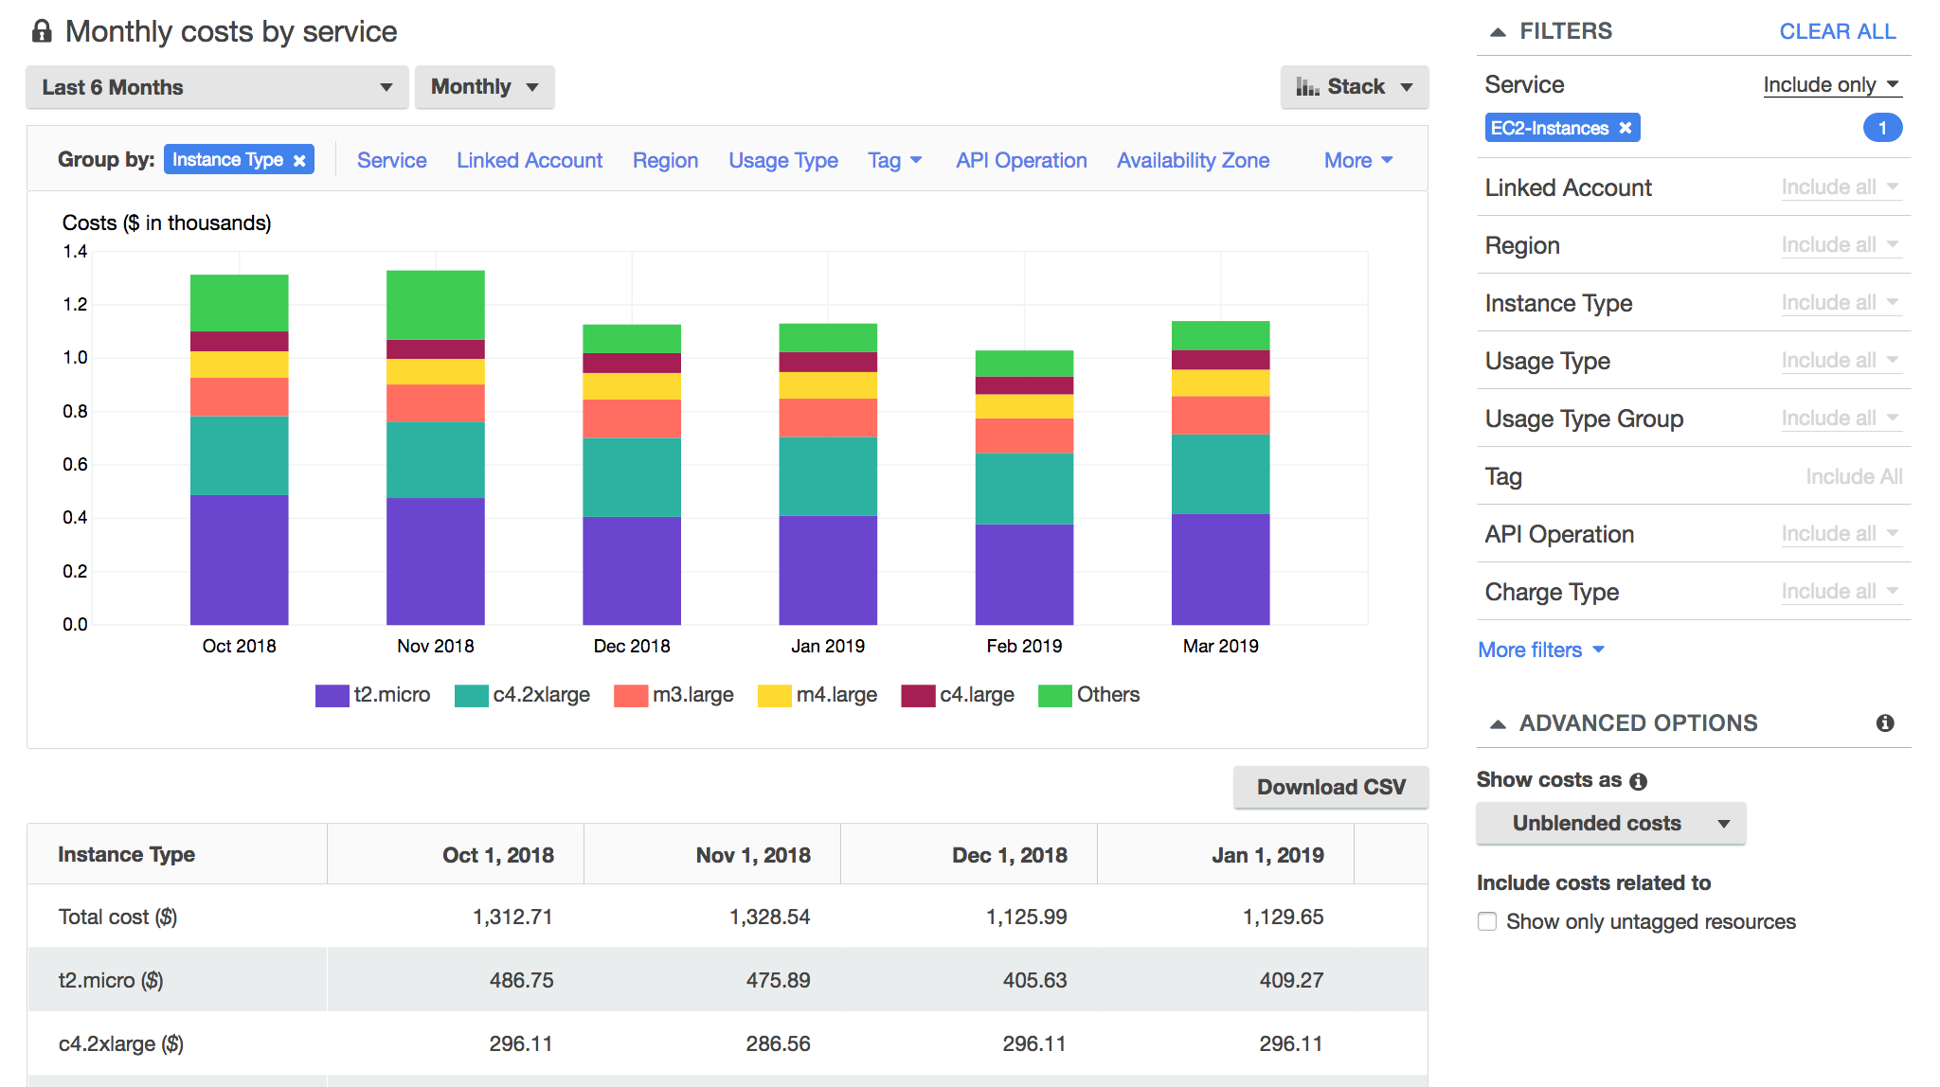

## 

## **Module 41: AWS Partner Network (APN)**

APN Consulting Partners helps customers of all types and sizes design, architect, build, migrate, and manage their workloads and applications on AWS, accelerating their journey to the cloud.

APN Technology Partner refers to organizations that are developing their own products/services that they will deploy on top of AWS to sell it to the customers.

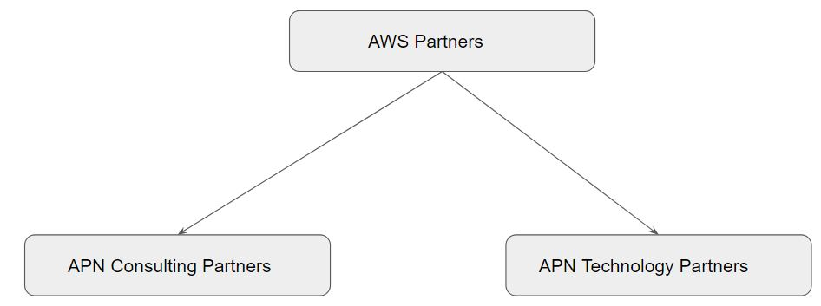

## **Module 42: AWS Marketplace**

AWS Marketplace is a catalog with thousands of software listings from third-party independent software vendors which makes it easy for customers to deploy solutions in AWS.

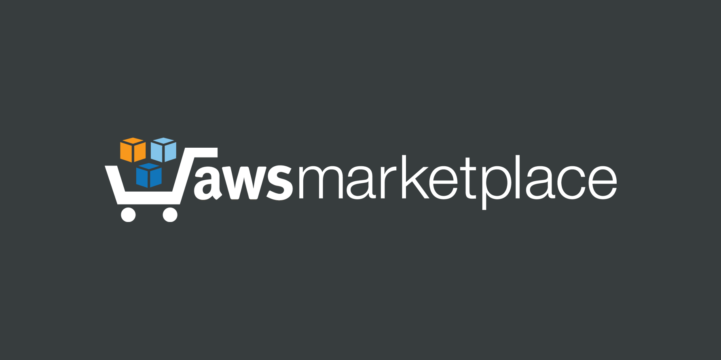

## 

## 

## 

## **Module 43: AWS Budgets**

AWS Budgets gives you the ability to set custom budgets that alert you when your costs or usage exceed (or are forecasted to exceed) your budgeted amount.

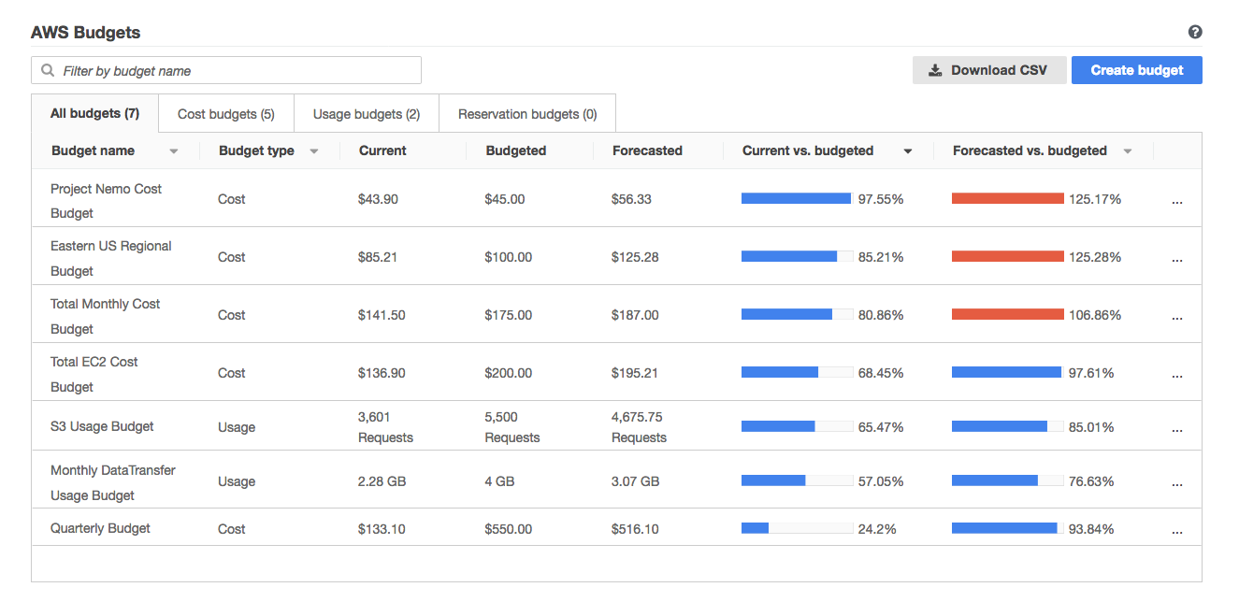

## 

## 

## 

## **Module 44: AWS Abuse Reports**

If you are facing any attack from AWS owned IP address, you can contact the AWS Abuse Team by filing a report.

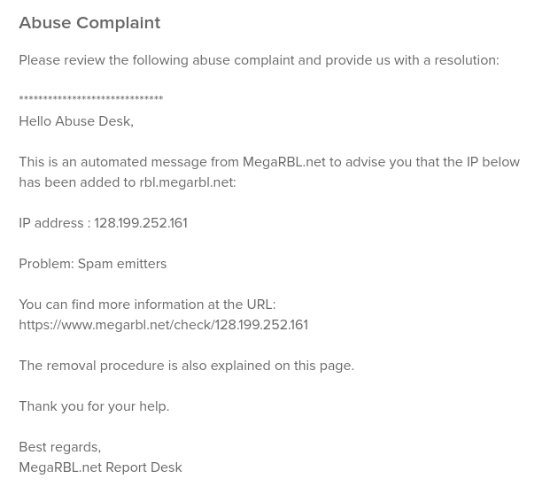

## 

## 

## **Module 45: Disaster Recovery Techniques**

## Broadly classified into four types:

## 

## i) Backup & Restore

## ii) Pilot Light

## iii) Warm Standby

## iv) Multi-Site

## 

## Multi-Site is one of the best architectures. Architectures designed with this approach have the lowest probability of downtime, but the cost of this approach is very high.

## 

## **Module 46: AWS Athena**

AWS Athena is a service that allows us to analyze various log files from S3 using standard SQL

## **Module 47: AWS Inspector**

AWS Inspector is similar to a vulnerability scanner that will scan the system for specific assessment rules and provide the results.

Catchword: Vulnerabilities

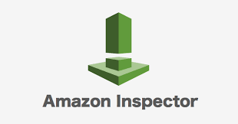

## **Module 48: AWS Macie**

AWS Macie can be used to recognize sensitive information like PII data, DB backups as well as data related to intellectual property,

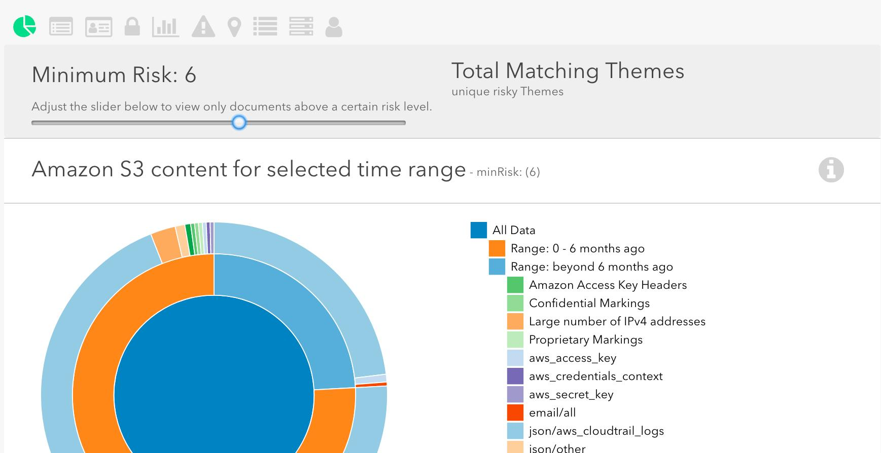

## **Module 49: Well Architected Framework**

The framework is designed with five pillars into consideration, namely:

* Operational Excellence
* Security
* Reliability
* Performance Efficiency
* Cost Optimization

## 

## 

## 

## **Module 50: AWS Storage Gateway**

AWS Storage Gateway is a hybrid storage service that allows the on-premise application to easily use the cloud storage

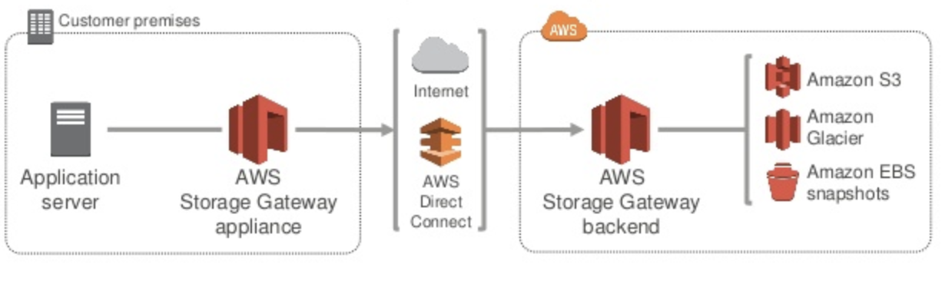

## 

## **Module 51: IAM Groups**

If you want to associate a specific set of permissions to multiple IAM users, you can add those users to an IAM group and add permission to the group.

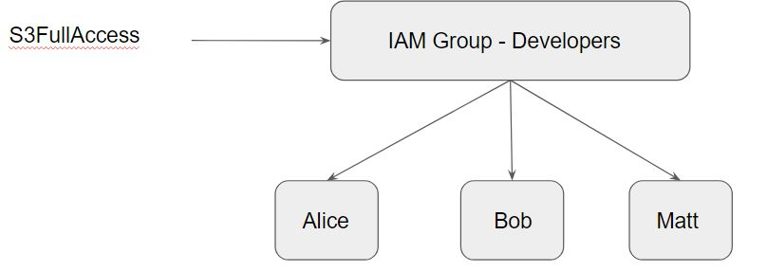

## **Module 52: CloudFront**

If you have your website running in one region, however, users are spread across the world, then you can decide to make use of CloudFront to reduce the latency.

* CloudFront in-turn, uses edge-locations to speed up things.
* Can also provide fast response time to frequently accessed data.
* Catch-Word: Content Delivery Network

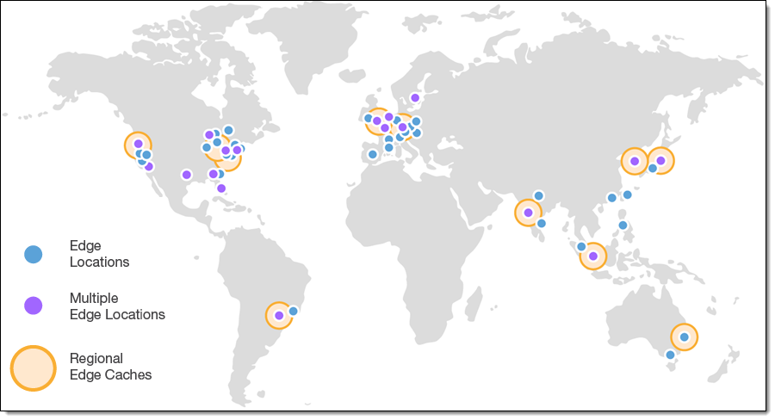

## **Module 53: Compute Service**

There are multiple compute service available, some of them includes;

* AWS EC2
* Lambda
* Auto-Scaling
* Elastic Beanstalk

If the question states managed to compute service, then Lambda is the right option.

## **Module 54: Hybrid Connectivity**

For hybrid architectures [internal networks], two options can be used:

* AWS Direct Connect
* Virtual Private Network (VPN)

If a consistent and dedicated connection is required, AWS Direct Connect is a better option.

## 

## 

## **Module 55: Cost Related Pointers**

Capital expenditure or capital expense is the money an organization or corporate entity spends to buy, maintain, or improve its fixed assets such as data-center, servers, hard-disk drives, firewalls, and others.

Operational Expense is an ongoing cost for running a system.

Cloud Computing allows customers to fully trade their capital expenses with operational expenses.

Three are multiple ways to identify the cost associated with each department.

1. Tag the resource and use the tags to analyze the cost.
2. Use multiple AWS accounts for each department. [useful for isolating costs as well]

For EC2 dedicated host reservation, All Upfront pricing option provides the largest discount.

## **Module 56: Miscellaneous Important Pointers**

Directory Service can be used to enable Single Sign-On (SSO) to AWS console.

Asset Management in the data-center is a little challenging, and dedicated tools and efforts are required to track every asset across all the locations. With Cloud, it is much easier as with just a few CLI commands, administrators can gather metadata information of all the assets.

RDS can also be deployed in multiple Availability Zones, and this design is used to protect against failures [high availability]

For increasing security for AWS logins, you can consider using MFA + Strong Passwords.

If you want to have a self-managed database, you can make use of EC2.

AWS Shield is the service for DDoS protection that provides always-on detection and inline mitigation.

IAM role is an entity that defines a set of permissions for use with an AWS resource.

Elastic Beanstalk can handle capacity provisioning, application health monitoring, load balancing as well as auto-scaling with just a click of a button.

Network ACL is part of VPC.

If you are facing spam or attack by a specific set of IP addresses, you can block them at the Network ACL level and even WAF.

If you want to quickly get information about the security group that has allowed unrestricted access (0.0.0.0/0) over some ports, then the easiest way is to use AWS Trusted Advisor service.

AWS Key Management Service (KMS) can be used for encryption of EBS volumes.

AWS Organizations provides a quicker and automated way to create and manage AWS accounts.

Additional Pointer:

If you are running an EC2 instance for 2 hours, 15 minutes and 8 seconds then you will be charged for exactly 2 hours, 15 minutes and 8 seconds.

## **Module 57: Amazon Polly**

Amazon Polly is a service that turns text into lifelike speech.

It allows you to create applications that talk, and build entirely new categories of speech-enabled products

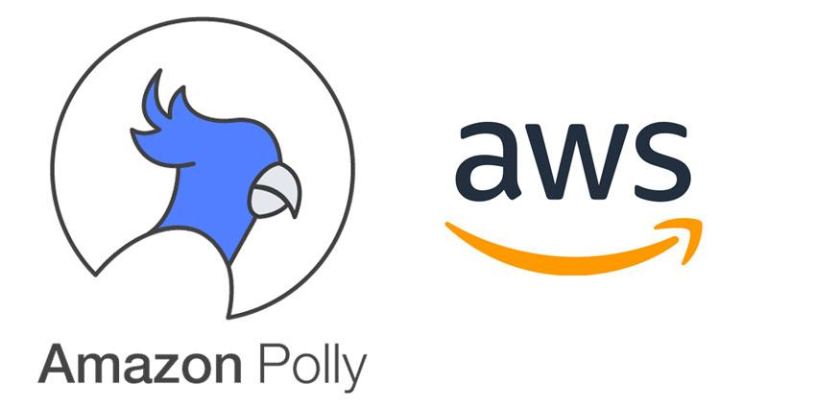

## **Module 58: Patching Activity**

Under the Shared Responsibility model, depending on the service, the responsibility for patching differs.

Updates = Patching

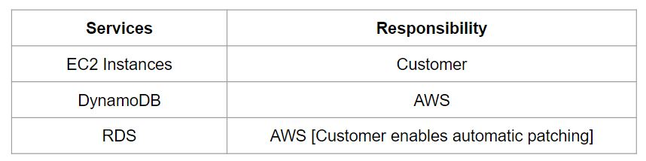

## 

## 

## **Module 59: Dealing with Suspended AWS Account**

AWS Account can be suspended due to various reasons.

One of the common reasons is related to non-payment.

You can contact AWS Support in such cases.

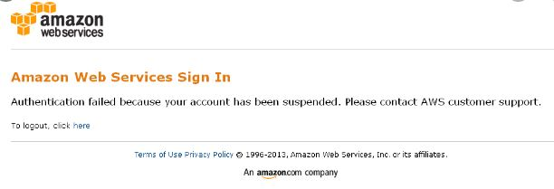

## 

## **Module 60: Dealing with Billing Issues**

There can be billing issues that might occur in your AWS account.

For such cases, you can contact the AWS Support with all the necessary details

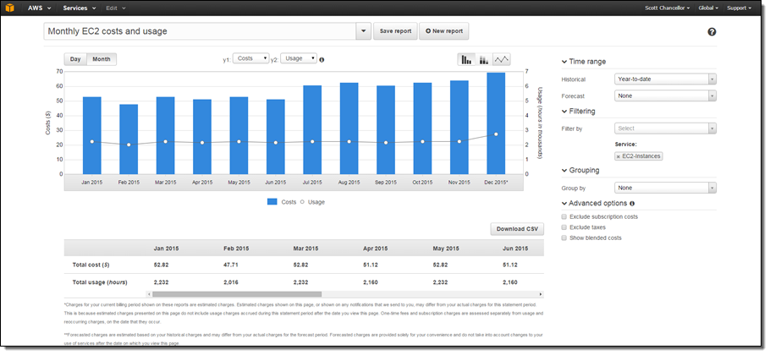

## 

## **Module 61: S3 Public Block Access**

S3 Public Block Access can be used to block any public access to the S3 bucket.

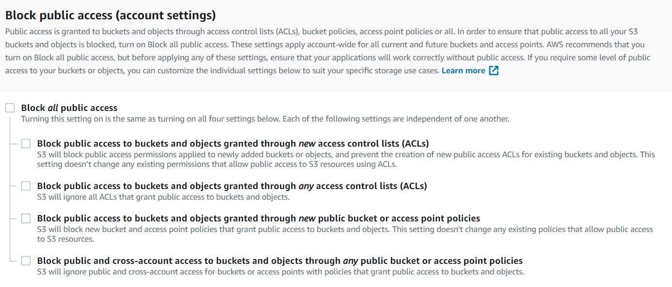

## 

## 

## **Module 62: CloudWatch Logs**

CloudWatch Logs can be used to monitor, store, and access your log files from Amazon Elastic Compute Cloud (Amazon EC2) instances, AWS CloudTrail, Route 53, and other sources.

Any use-case where you want to monitor and receive alerts when “ROOT” user has signed in, you can make use of this service.

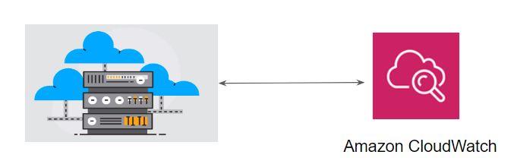

## **Module 63: Transit Gateways**

A transit gateway is a network transit hub that you can use to interconnect your virtual private clouds (VPC) and on-premises networks.

AWS Transit Gateway helps you build applications spanning thousands of Amazon VPCs.

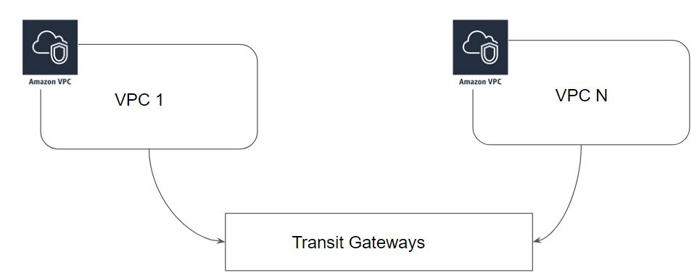

## 

## 

## **Module 64: Key Management Service**

AWS Key Management Service (KMS) allows us to generate and manage keys that can be used to encrypt and decrypt the data.

Encryption is important so that no unauthorized users can see the plain-text contents of your data.

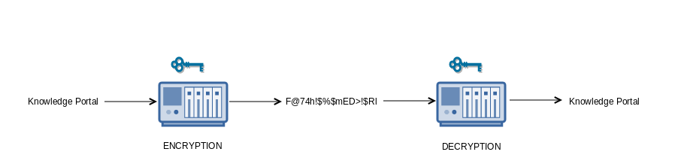

## 

## 

## **Module 65: Economies for Scale**

Economies of scale are cost advantages reaped by companies when production becomes efficient. Companies can achieve economies of scale by increasing production and lowering costs.

The continual reduction of AWS Cloud pricing is due to economies of scale

## **Module 66: AWS Auto Scaling**

With AWS Auto Scaling, you configure and manage to scale for your scalable AWS resources.

There are multiple resources that can be scaled like EC2, DynamoDB, Aurora.



## **Module 67: AWS Organization for Policy Management**

AWS Organizations can be used to restrict AWS services and individual API action of every member account.

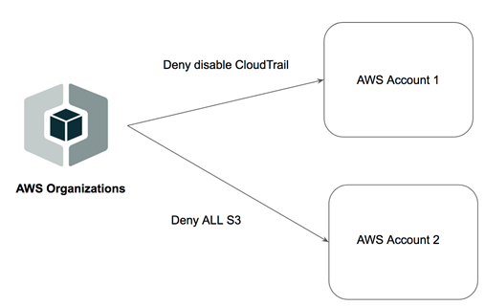

## **Module 68: AWS Well-Architected Framework**

The Well-Architected Framework has been developed to help cloud architects build secure, high-performing, resilient, and efficient infrastructure for their applications.

The framework is designed with five pillars into consideration, namely:

* Operational Excellence
* Security
* Reliability
* Performance Efficiency
* Cost Optimization

AWS Config for auditing, evaluating changes belongs to the “Security” pillar.

## 

## **Module 69: AWS Global Accelerator**

AWS Global Accelerator is a service that improves the availability and performance of your applications with local or global users.

Two Important Benefits: Improved Availability and Decreased Latency

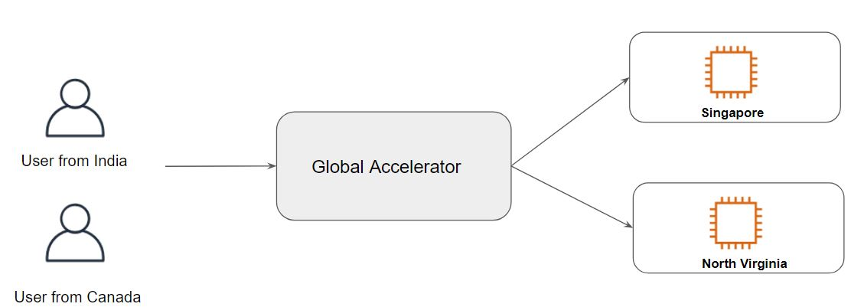

## **Module 70: VPC Flow Logs**

VPC Flow Logs is a feature that enables you to capture information about the incoming and outgoing traffic in an AWS VPC.

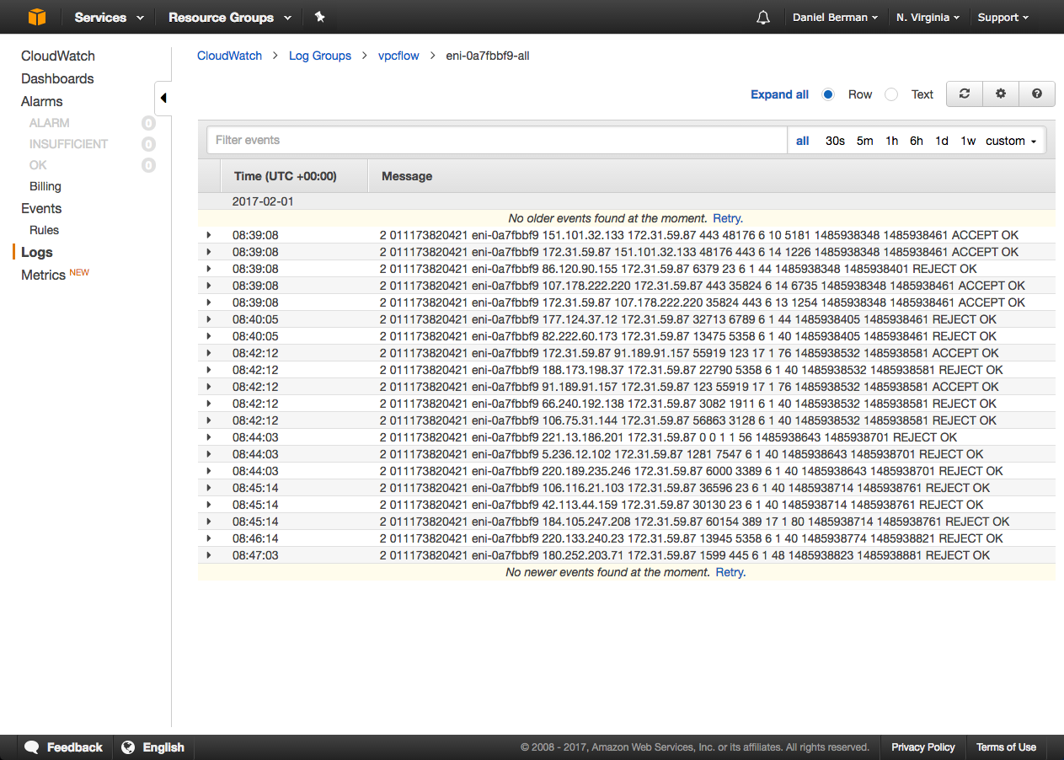

## 

## **Module 71: Miscellaneous Pointers**

Trusted Advisor can be used to monitor service limits in your AWS account.

AWS Support API is available for AWS Support customers with Business and Enterprise support plan.

AWS Compute Services: EC2, Lambda, Batch, Lightsail

Various services like Snowball, Data Migration Service (DMS) can be used to move data from on-premise to AWS.

AWS Guard Duty can be used to identify malicious or unauthorized activities in AWS accounts

CloudHSM is a dedicated appliance that can be used for data security and encryption.

AWS Cost Explorer can be used to forecast AWS spending.

AWS has a set of solutions to help you with cost management and optimization. This includes services, tools, and resources to organize and track cost and usage data.

These tools allow customers to break down AWS costs as well as create budgets and notifications.

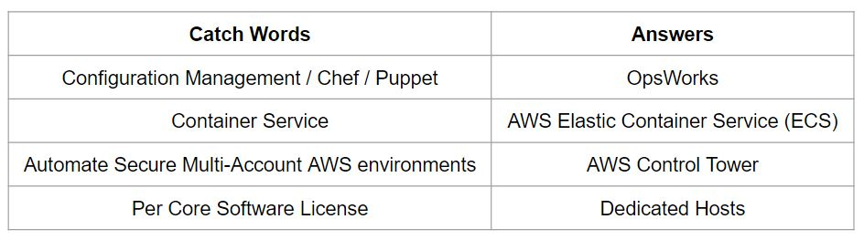

## **Module 72: Developer Tools**

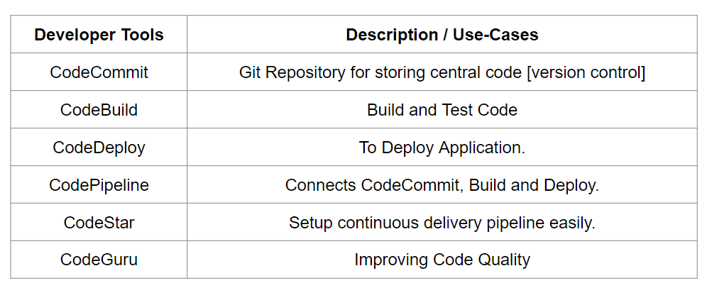

## **Module 73: Generic Pointers - Part 1**

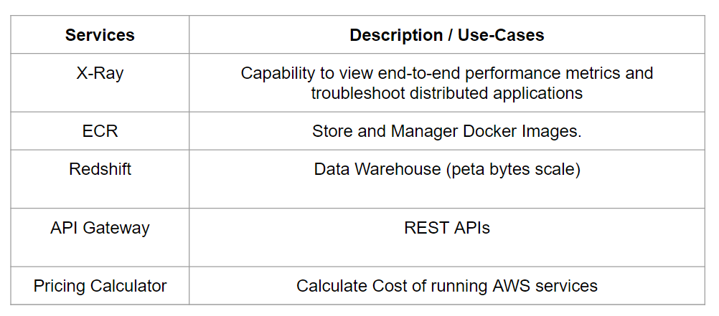

## 

## **Module 74: Generic Pointers - Part 2**

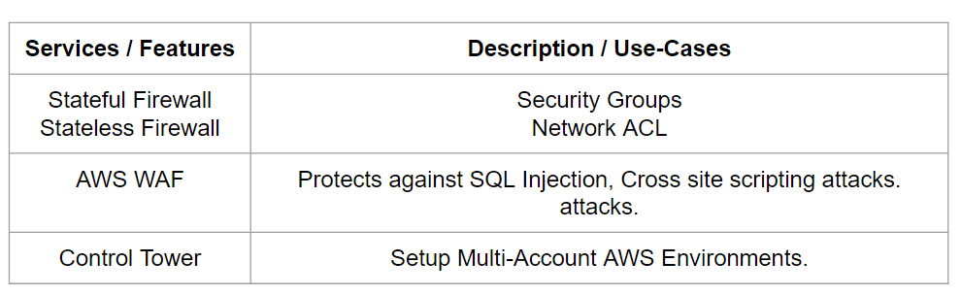

## 

## **Module 75: Generic Pointers - Part 3**

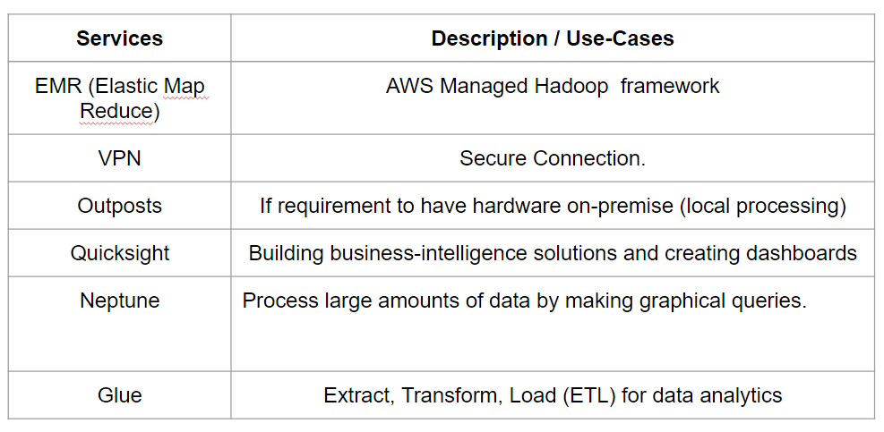

## 

## **Module 76: Generic Pointers - Part 4**

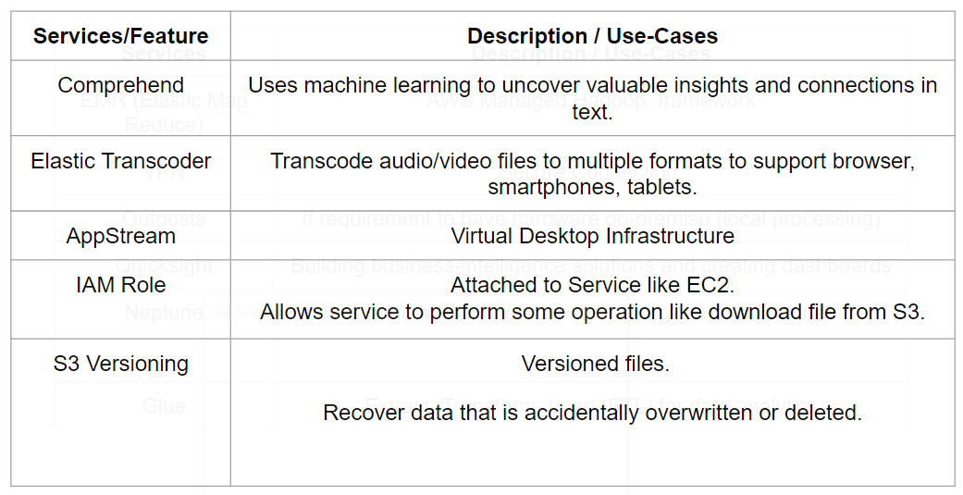

## **Module 77: Task That Requires ROOT user**

Not All tasks can be performed with IAM User. Certain task require a ROOT user only.

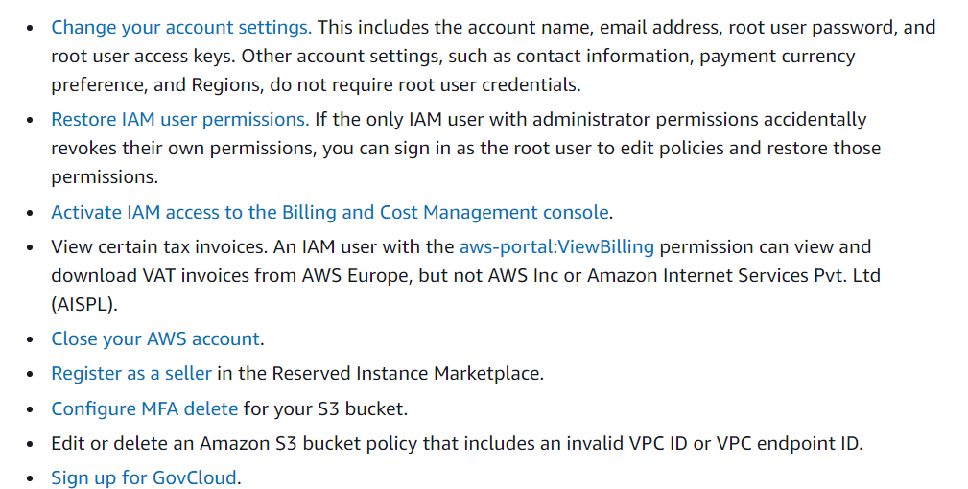

## **Module 78: Service Quotas**

Service Quotas (Limits) is an AWS service that helps you manage your quotas for many AWS services

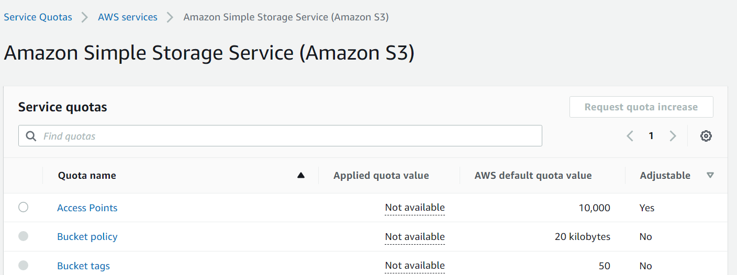

## **Module 79: Local Zones**

A Local Zone is an extension of an AWS Region in geographic proximity to your users.

You should use AWS Local Zones to deploy workloads closer to your end-users for low-latency requirements.

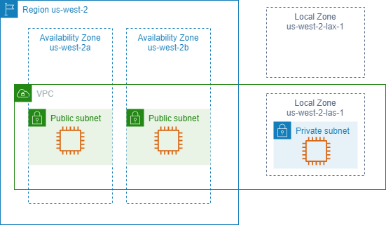

## **Module 80: Terminologies**

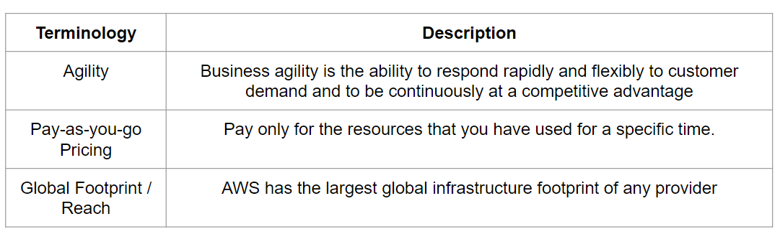

## **Module 81: Loosely Coupled Components**

Loosely coupled components is design principle so that those components of a system depend on each other to the least extent practicable

Helps isolate failure between dependent components.

SQS service helps in designing loosely coupled components.

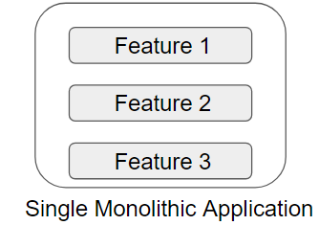

## 

## **Module 82: IAM Access Analyzer**

AWS IAM Access Analyzer provides the following capabilities:

IAM Access Analyzer helps identify resources in your organization and accounts that are shared with an external entity.

IAM Access Analyzer validates IAM policies against policy grammar and best practices.

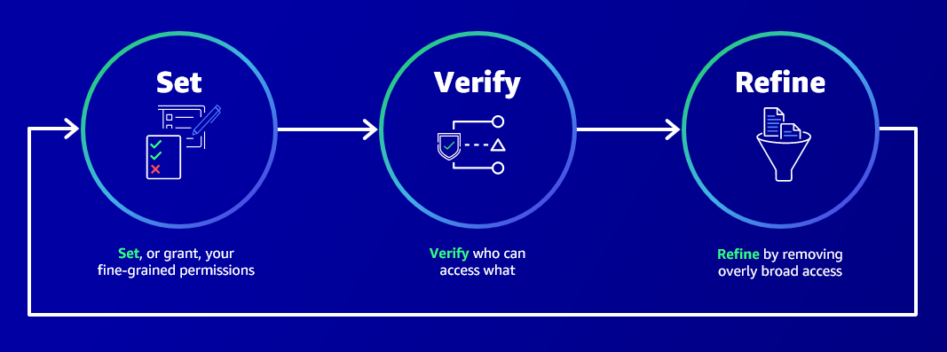

## 

## 

## **Module 83: Internet Gateway**

An internet gateway is a component that allows communication between your VPC and the internet.

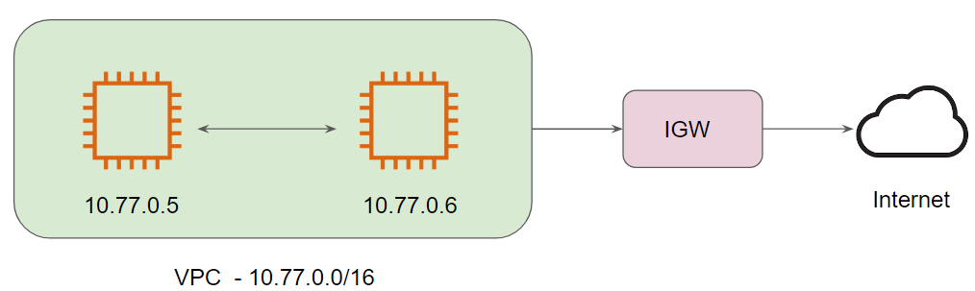

## 

## **Module 84: Snowball Edge**

AWS Snowball Edge is a type of Snowball device with on-board storage and compute power for select AWS capabilities

Collect, Format, and process the data offline (without internet) and later move to AWS when internet is available.



## **Module 85: Container Services**

* For Container Orchestration.
* Both supports Fargate integration.
* Container across multiple platform = EKS
* KEEP it Simple = ECS.

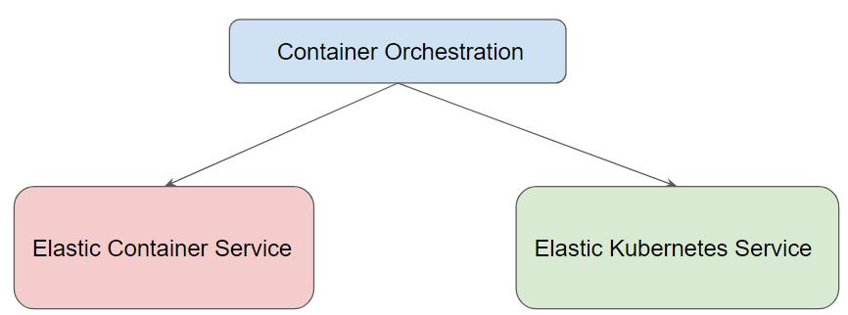

## 

## 

## **Module 86: Service Catalog**

Managed catalogs of IT services that are approved for use on AWS.

Portfolio of predefined AWS resources.

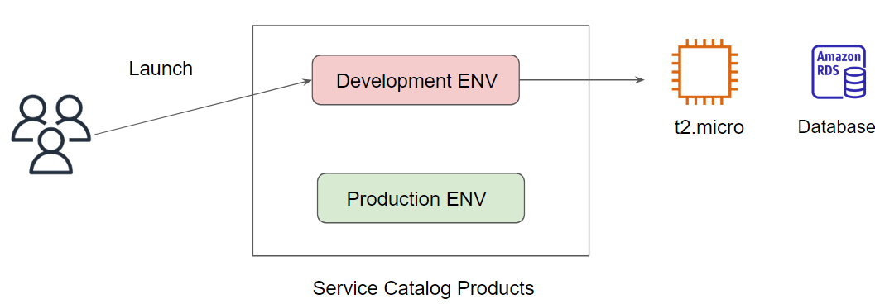

## 

## **Module 87: Miscellaneous Pointers**

Deploying AWS Services: Console (GUI), CLI, Software Development Kits (SDK) (programatically)

Fargate - Serverless compute for containers (automatically provision and manage resources / instances)

Use-Case related to migrating small website quickly (with less knowledge) to AWS, Lightsail is a better option.

EBS Snapshot - Backup of EBS Instance. Helps during the Disaster Recovery stage.

Amazon Connect is used to manage phone calls and for setting up phone numbers for customer support.

## **Best of Luck for Exams, Rockstar!**



## **Join Our Discord Community**

We invite you to join our Discord community, where you can interact with our support team for any course-based technical queries and connect with other students who are doing the same course.

Joining URL:

<http://kplabs.in/chat>

